Docker Engine installed :

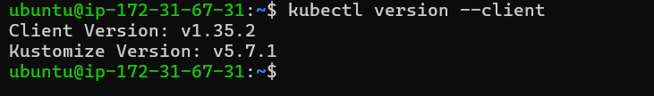

Minikube installed :

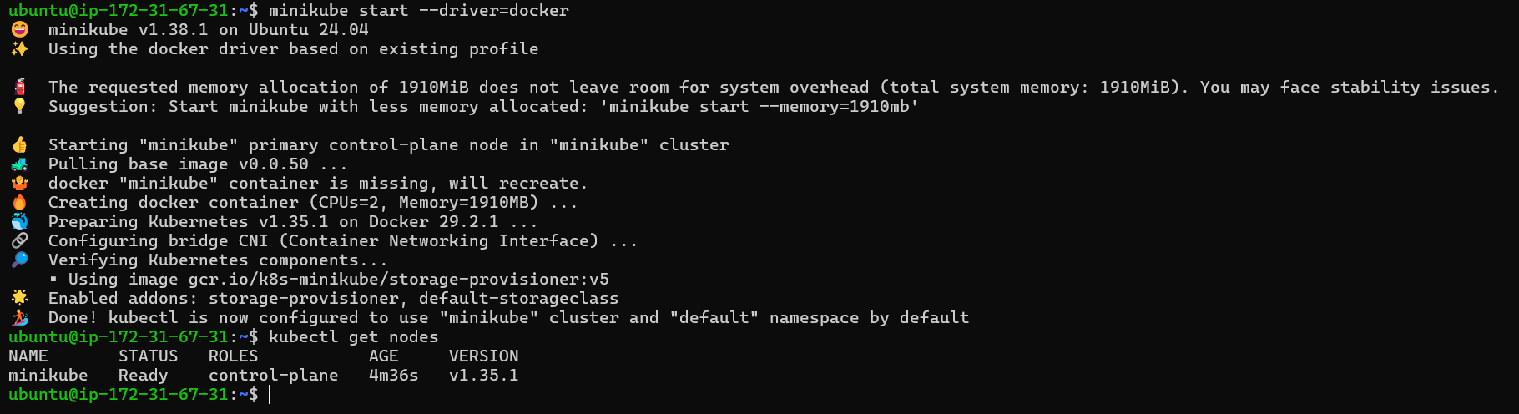

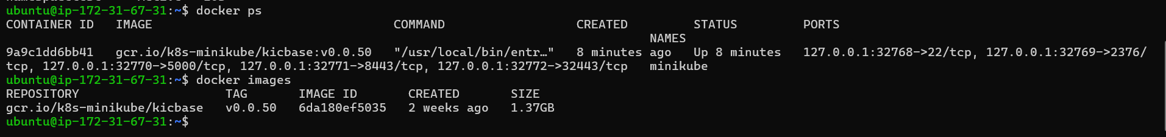

Existing Namespace :
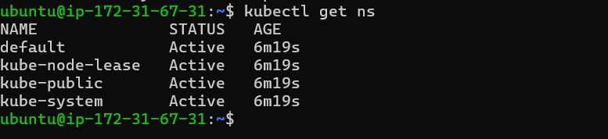

Namespace Created :
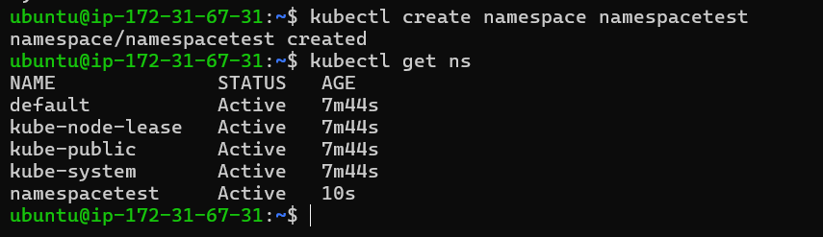

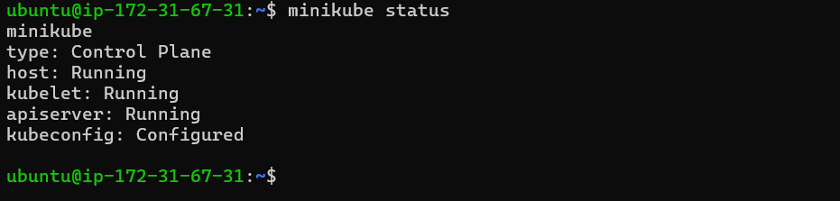

Created Pod in new namespace :
